Photo editing project rough idea
Zunlin Zhang

UI
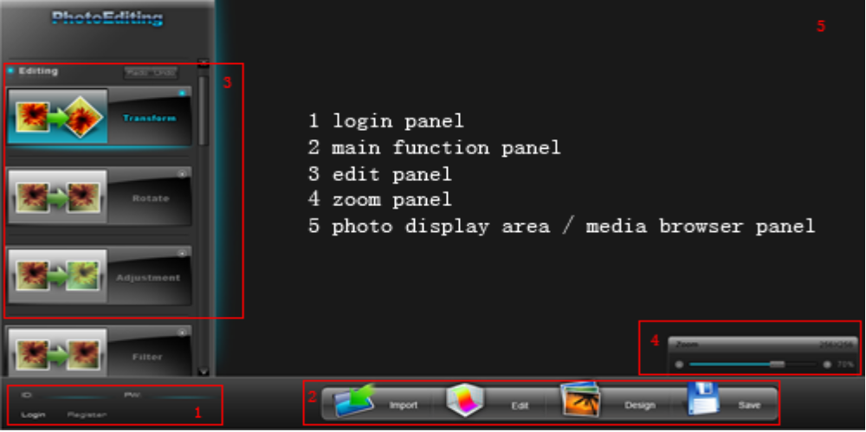
The main UI of photo editing contains five parts as showed above:
- Login panel
This panel is for user login or register to Roxio account. The photo editing can be used without login. User can upload a photo from his computer and download it back after does some edit work. We may also support load image from Roxio.tv media library if user login with his Roxio account.

- Main function panel
This panel contains four parts:
  - Import
Import image file from Roxio.tv media library, user’s hard disk or other online photo blogs.
  - Edit
Some common edit function will be supported in editing mode. They are Transform, Rotate, Adjustments and Filter.
  - Design
In this mode, user can add some widgets, text or frames to their photo.
  - Save
Maybe we can support save the photo back to user’s Roxio.tv media library or just let it be downloaded back to user’s computer.

- Minor function Panel
This panel will be loaded according to different function calling from main function panel. When user click some function in panel 1, relating minor functions will be showed up in this panel. For example, after Import has been selected, four big icons (Roxio.tv, Hard disk, Fliker, Facebook) will fly into this panel.

- Zoom Panel
This panel will be showed up only in Edit mode. A slide bar can be used to zoom the photo which is now in editing.

- Photo edit area / Media browser
  - After a photo was imported, it will be showed up at this area. Any edit action will be reflected to screen immediately. User can call Undo/Redo to roll back some edit actions.
  - If user wants to import photo from some media library (eg: Roxio.tv accout). All medias that can be edited by this software will be showed up here for browsing. We can put reflector under each image to make it look cool.

UI Animation
Animations will be only showed when loading the software. All panels will be showed up step by step.

- The bottom area which contains panel 1 and 2 will move into the screen from bottom slowly. Just like the Dock in MAC OS X. It will never hide after being loaded.
- The left area which contains logo and panel 3 will move in to the screen from left slowly. This panel will never hide after being loaded.
- After some main function was clicked, the relating minor functions will be showed up with fade in fade out effects one by one in panel 3. I’ll check if I can make this action like jelly. If some other main function clicked, the current minor function panel will be hided with fade out effect altogether.
- The blue light which at the right side of left area will be acted with a breath effect. This means the light will become strong then weak then strong continuing.

Go to the Photo Editing
The photo editing can be loaded from two ways.
- From Roxio.tv
Users can load the photo editing to edit their photos from Roxio.tv. I’m now working on adding some tool bar in Clipwheel in Roxio.tv. Users just click some edit button, the photo editing web page will be loaded and open that photo directly.
- From product URL (eg: www.photoediting.com)
User can also load the photo editing by input the URL directly. In this way, he must import photo before edit. He can login to import photo from his Roxio account or just upload photo from his computer.

Editing
When in edit mode, the minor function panel contains four main function groups: Transform, Rotate, Adjustment and Filter.
The normal button is like 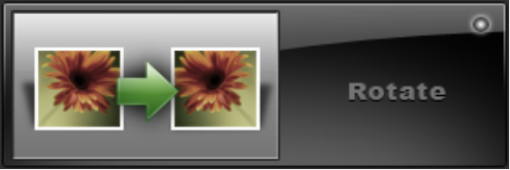.
When mouse over, it is like 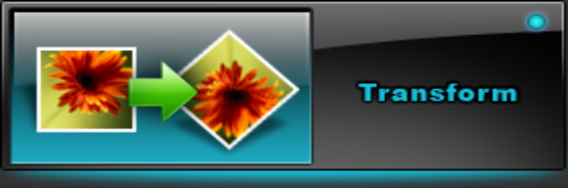. A beautiful blue light will show up behind the button.
When user click the button, the detail functions will fade in at the button position just like 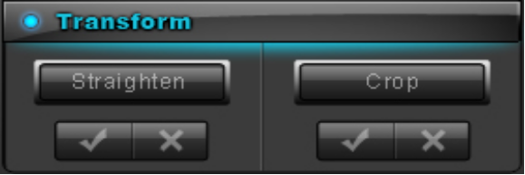. If user click other function group (eg. Filter), the current group will disappear with fade out and the new group will show up.

About the idea of function group
After visiting some online photo editing website, I found almost all website separate the edit functions. In picnik.com, it shows like:
I thought maybe most user don’t care what’s the name of some special function. They just want to know what these functions can do for them. So I group some functions refer to PhotoShop. I put Straighten and Crop into Transform group; Rotate and Mirror into Rotate group; Brightness, Contrast, Saturation and Hue to Adjustment group; Sharpen and Blur to Filter group. Also, I order these groups by Transform, Rotate, Adjustment and Filter. This is based on my own experience when edit photos after take them. I thought it is the right process flow, you do the transform first, then adjustment. Maybe we can make the group title more personality. Maybe the “Adjustment” should be “Beautify your photo”.
If user modify his photo step by step from Transform to Filter, they can make their photos beautiful easily. After that, user can go to Design panel to add some special widget to his photo.

